YOUNG & CONTENTS New Drama Series
Lhy8818@naver.com / +821037495573 / Hyo Young Lee(Mr.)
2025.10.

<Reverse​> 리버스
- Genre : Mystery, Melodrama, Revenge Drama
- Format : 60 min x 8 Episodes / - Writer : Lim Gun-jung
- Casts : Go Su, Seo Ji-hye, Kim Jae-kyung, Yoon Je-moon
- Director : Lim Gun-jung
- Channel & Release : Wavve / 2026.02 / Simulcast available
- Log Line: Myojin lost his parents in a mysterious accident when he was a child.
For 15 years she has endured only thinking about revenge,
the perfect opportunity presents itself, but...
She is involved in a car accident and loses all his memories.
New facts encountered in the process of chasing lost memories.
Driven by crises, they are forced to come close to a shocking truth.
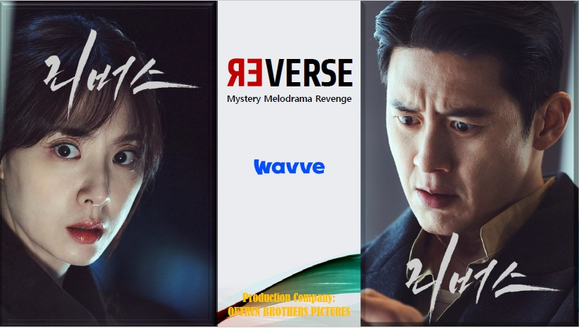
REVERSE_HL
https://vimeo.com/1129388859?share=copy&fl=sv&fe=ci
Password : 5442

<The Hidden Hikikomori Master: Baekho Tae> 은둔고수태백호
- Format : 30 min × 10 episodes (Total 300 min)
- Genre : Youth, Healing, Comedy, Investigation
- Casts : Jang Seong-beom, Lim Young Joo, KINO, Kim Hyun-kyu
- Platform&Release : OTT Platform / Jan. 2026
- Logline A warm and quirky rescue mission by a misfit task force for young people disconnected from the world
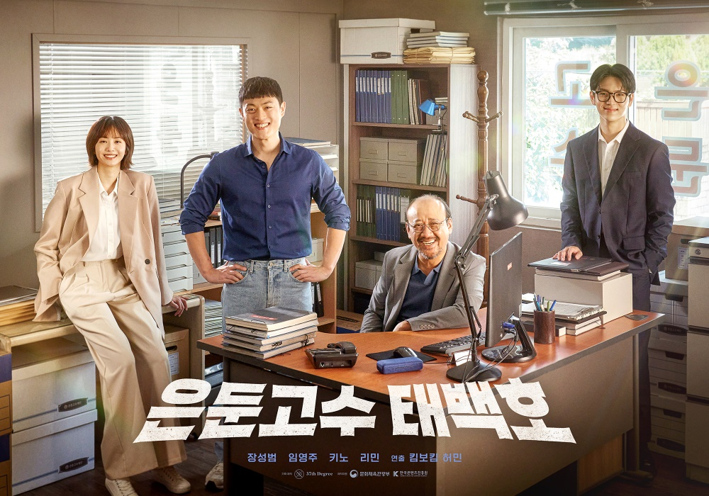
https://vimeo.com/1119081604/bbf64f20ae

<Someday of ME​> 미래의 미래
Genre: Romantic Comedy Drama
Format: 30min. X 6series / Platform : LG U+ tv, 28th November.
Director/Writer: Lim Gongsam
Logline: Gong Mirae, who represents the MZ generation, escapes from the fantasy of first love and sets off on an emotional journey to find her true self



https://vimeo.com/1135175957/125b32705e?share=copy&fl=sv&fe=ci

<First Love​> 퍼스트러브
- Genre : Romantic Comedy
- Format : 60 min x 6 Episodes(6 Different parts – Omnibus drama)
- Director : Park Seon-jae
- Writer : Kim Yu-jung & Ji Kang
- Casts : 1ep/Eun Chan, Jung Ji-su, 2ep/Cha Jun-ho, Hwang Ji-ah, 3ep/Lee Hyo-je, Lim Sung-jun,
Chun Ye-ju, 4ep/Park Sang-hun, Park Do-ha, Kim Sun-kyung, 5ep/Han Se-jin, Sung Ji-yeon,
6ep/Bong Jae-hyun, Lee Chae-eun
- Channel & Release : LGU+Mobile / 2025.04.18 ~5.23
- Log Line : 1ep/ The lovely story of the girl Bong-hee, secretly scorning his childhood friend Faran who became an idol
2ep/ A cranky schoolboy helps exchange student Hikari with her bucket list~
A clumsy love story between a Japanese boy and a Korean girl
3ep/ Hyungyu, who dreams of becoming an EDM DJ, has a crush on a girl who loves his half-brother ~
4ep/ Sunwoo and Jiyoon's first love story ~
5ep/ Philip, who grows slower than his peers, falls in love at first sight when he sees his teacher~
6ep/ A romance thriller that realizes Ina's heart through the school's ghost commotion

https://vimeo.com/1065794394/de151866e7
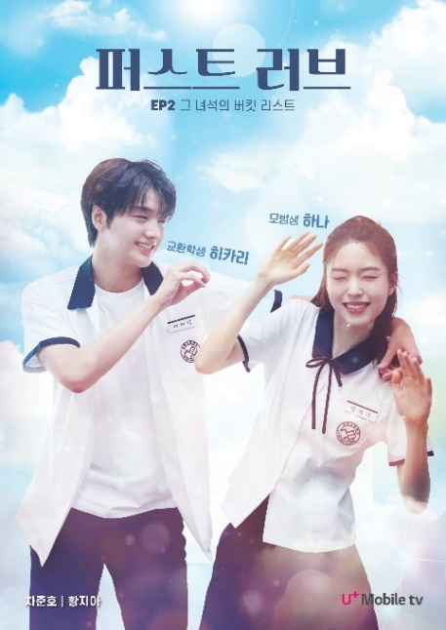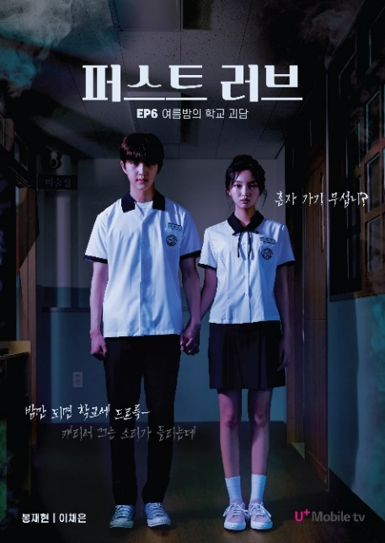

<Bulk Up​> 벌크업
Title: Bulk Up
Episode Format: 30 min × 10eps
Writer/Director: KWAK Jung
Release : Wavve, 2025.07.25
Starring: Oh Jin-seok, Choi Ye -jin, Lee Jae-bin, Lee Yoon
Genre: Coming-of-age, Comedy, Romance
Synopsis: Soo-in is rejected for being too skinny. Sun-hee is dumped for being overweight.
Young people seeking a dramatic turnaround in life gather at a gym!
To take advantage of the "couple discount," Soo-in and Sun-hee register for gym membership pretending to be a couple. Can they level up both physically and emotionally for a better tomorrow? A sweat-filled gym becomes the setting for a fresh new take on youth romance and personal growth. A youth fitness rom-com full of charm, sweat, and emotional gain!
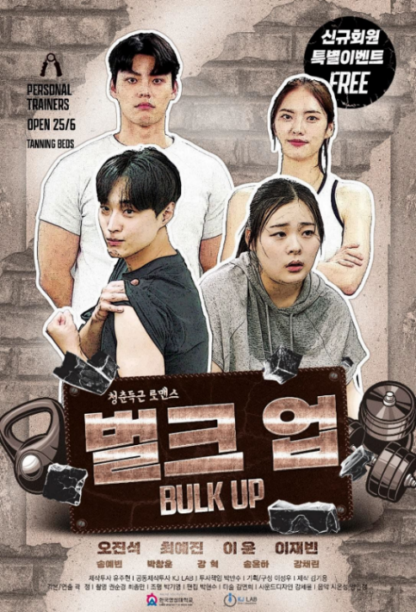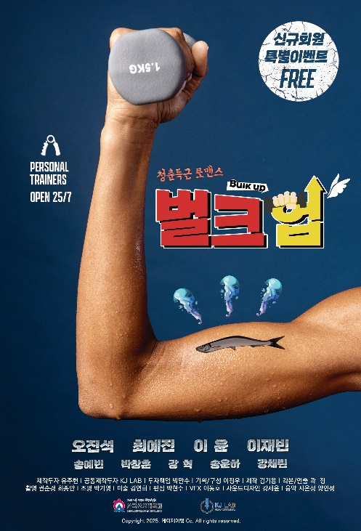
https://vimeo.com/1093925609/c8f869e8e3

<Where’s My Hero?​> 남주써치
- Genre : Youth Romantic Comedy
- Format : 30 minutes X 6 episodes (Season 1)
- Casts : Kal So-won, Lee Jin-woo, Cha Jun-ho
- Release : 2025.06.27 Released by Wavve
- Logline : Searching for her vanished in-game fiancé, Seollem ends up discovering unexpected love in the real world. A new concept mystery love triangle with a comedic flair.

https://vimeo.com/1097397103/b0bda39ba0

<I Kill U​> 아이킬유
- Genre : Hard-Boiled Action
- Format : 30 min x 6 Episodes
- Writer : Koh Jae-hong, Wang He-ji
- Casts : Kang Ji-young, Lee Ki-kwang
- Director : Yoo Ha
- Channel & Release : Wavve, Watcha / 2025.08.22 / Simulcast available
- Log Line: A cruel fairy tale story of survival and revenge for a dirt-spoon woman, fallen into the inescapable trap by a silver-spoon troublemaker who resembles her
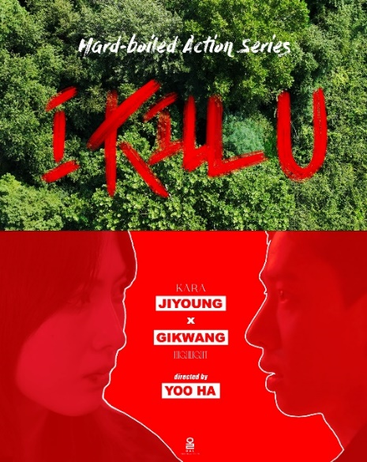https://vimeo.com/1065790615/69d3756a89?share=copy

<22 Ways to Say Goodbye with Grace​> 행이22
- Genre: Romantic Comedy / Coming-of-Age
- Format : 16 episodes x 60 minutes
- Multi-layered emotional storytelling
- Format-diversity: short form + mid form + full episodes
- Channel : Discussing with MBC(2nd half of 2026 year)
- Casts : Lee Sin-young, Jeong Ji-so
- Logline : A coming-of-age chronicle built on breakups. life is a series of goodbyes-but every ending can be a new beginning.
- Storytelling :
A decade-long chronicle of love and separation shared by Jeong-hee and Hyeong-min. From their naive high school days through passionate college years to adulthood, the series tracks their 22 unique breakups, exploring what it means to truly love—and grow.
This is not an omnibus. The 22 stories are tightly interwoven, each breakup leading into the next like a domino effect.It captures the emotional compression of stand-alone dramas and the continuity of serialized storytelling.
A perfect marriage of independent film-style efficiency with deep K-drama narrative arcs.


<Modern Sharehouse​> 모던쉐어하우스
- Genre: Human Comedy
- Format : 12 episodes x 60 minutes
- Channel : Discussing with ENA(2026 year)
- Casts : Main Actor –Bae In-hyuk
Main Actress – Jin Ki-ju
- Logline : A hanok that was remodeled from an old house.
Paradoxically, this place is named Modern Share House.
People who have no special purpose but come here for
their own reasons. Strangers with different backgrounds
and values gather under one roof, sometimes conflicted,
sometimes comforting, and finding the true meaning of 'togetherness'

YOUNG&CONTENTS New Entertainment Shows
Lhy8818@naver.com / +821037495573 / Hyo Young Lee(Mr.)

<The Greatest Show : Taekwon>
GENRE: Reality + Survival
RT: 90min x 8eps
On-AIR : 2025.06.27(Friday) ~ 08.15 / 10:40 PM
Casts : Park Karl-lin, Jang Seong-kyu, Na Tae-ju, Lee Yu-ree, Kwak Taek-yong
Production : SN Creative Culture Co.,Ltd / Studio & Creative
Summary : An audition entertainment program in which martial artists and foreigners from various fields such as domestic and foreign taekwondo national teams, athletes, and demonstration troupes to dance and parkour take on the challenge and select the last one standing.


<Listen Page​>

GENRE: K-POP Music Entertainment & Talk Show
RT: <Season1> 60min x 10ep / <Season2> 30min x 10ep

★ SEASON1 Line-Up ★
⁕ MC Jinwoo (WINNER) + D1 (DKB)
Episode 1 : DKB , Hui / Episode 2 : n.Ssign, VANNER / Episode 3 : AMPERS&ON. XODIAC / Episode 4 : EPEX , 82 Major / Episode 5 : Lucy , Soran (Band Team Special) / Episode 6: WHIB, NOWADAYS, CRAVITY / Episode 7 : CLASS:y, A.C.E, JAY B (GOT7) / Episode 8 : ONEWE, TOUCHED / Episode 9 : POW, CIX, Wei / Episode 10 : ALL(H)OURS, n.Ssign, DKB

★ SEASON2 Line-Up ★
⁕ MC Kevin(The Boyz) + D1 Dark Bee(DKB)
Episode 1 : EVNNE / Episode 2 : TEMPEST / Episode 3 : 82MAJOR /
Episode 4 : NouerA, 3WAY, LUN8 / Episode 5 : CLOSE YOUR EYRS, Fantasy Boys, GENBLUE / Episode 6 : Xikers / Episode 7 : Pentagon Hui / Episode 8 : P1 Harmony / Episode 9 : FIFTY FIFTY / Episode 10 : TBD

** TV & OTT Rights (Including Simulcast) & Concert Tour Rights are available.

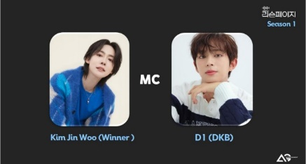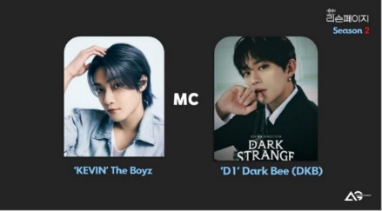

YOUNG&CONTENTS New Documentaries
Lhy8818@naver.com / +821037495573 / Hyo Young Lee(Mr.)

<Back to The Books​>
- Genre : documentary
- Format : Season1 4eps+Season2 4eps+Season3 4eps = Total 12eps
- Release : S1-2019 / S2-2022 / S3-2023
- Channel : JTBC / TV Chosun
- Logline; In the digital age, actor Jang Dong-gun finds the value of human beings. In a forests of
books, visiting the most beautiful bookstores in the world, he seeks a slow utopia of life.
<Season1> China / France / Japan / Korea
<Season2> Netherlands / UK / Austria / Greece
<Season3> Argentina / Russia / Hungary / Taiwan

https://vimeo.com/412164713 Passcode: young

YOUNG&CONTENTS New Animation Series

<Jurassic Cops​>
- Genre: Action Hero
- Target: 4 to 7-year-old children(sub-target: 3~5 years old kids)
- Format: 3D CGI Animation
- Production: HD TV series Animation (11 minutes x 104 episodes
- On-Air: July 7th, 2018~ 2PM on KBS1TV
- Status of overseas distribution: INDONESIA -NET-TV, RUSSIA- KINO/IVI/OKKO, THAILLAND-
CARTOON TV
- Outlook: Guardians of the Earth! 65million years ago, 5 members of Jurassic Cops locked ‘DeathVarian’, who invaded the Earth, in the moon. In present days, Jurassic Cops, in forms of vehicles, live in the Earth. The earth’s alter ego, Dr. Joo, who is also the leader of Jurassic Cops was looking for a new leader.. And… He appoints Gongchan as a Jurassic Commander…. Go Fight! 5 Jurassic Cops! Jurassic Evolution!!
(Pre-School - Animation - Series) (All rights available including Merchandising)


https://www.youtube.com/watch?v=ecSdALTby7I&list=PLcFCVhJUXLKvQUMDAkq3XGoj7FUDvG_O4

<Dinoman​>
- Genre: Time Adventure
- Target: 4 to 4-year-old children(sub-target: 4~7 years old kids)
- Format: 2D + 3D CGI Animation
- Production: HD TV series Animation (7.5 minutes x 80 episodes
- On-Air: S2/23.07 MBC, S3/24.07 MBC
- Status of overseas distribution: Indonesia -NET-TV, Taiwan YoyoTV, RUSSIA CIS VOD TV,
Hongkong VIU, Singapore CH5/ Philippins ABS-CBN / Malaysia VIDIO / China
- Logline: The Time Expedition Dino Man is the cute little dinosaur Dino Man, Kera Girl, Pteraman, and Bronto Man ride a time machine. Time travel to solve the difficulties of extinct
animals. Time Adventure Free School Animation!
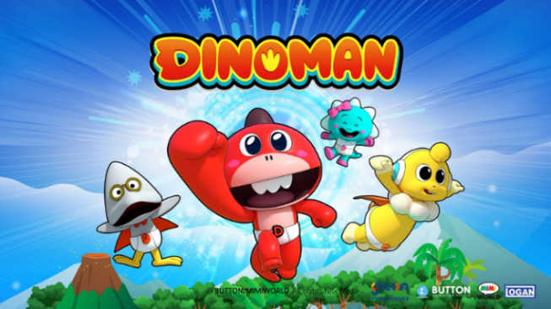
https://www.youtube.com/watch?v=MJC4QAe7U-4&list=PLcFCVhJUXLKvJEBgIuyLExSGoLVYZcxwK&index=2

<SHAPES​>
- Genre : Emotional Slapstick, Comic Sitcom
- Format : TV Series, 6 min x 26 Episodes(Season1)
- Production : LIMFACTORY(Ko) & Eracartoon(Cn)
- Target Audience : Ages 2~6 / - Platform : KBS / 2024.08.20 ~
- "SHAPES" is a character and animation content that personifies basic
geometric shapes - square, circle, triangle, as well as primary colors - red,
yellow, and blue. Through comical and sometimes emotional portrayals,
Shapes convey their unique perspectives on the world, aiming to send warm
messages to viewers of all ages, including children, who watch and enjoy
their adventures together.
(Pre-School - Animation - Series) (All rights available including Merchandising)
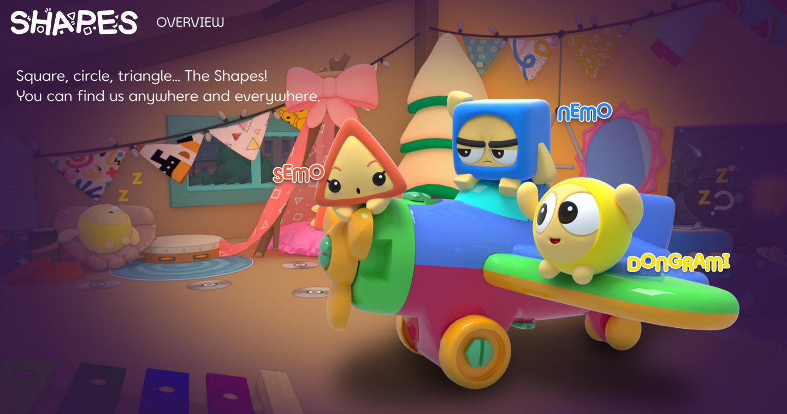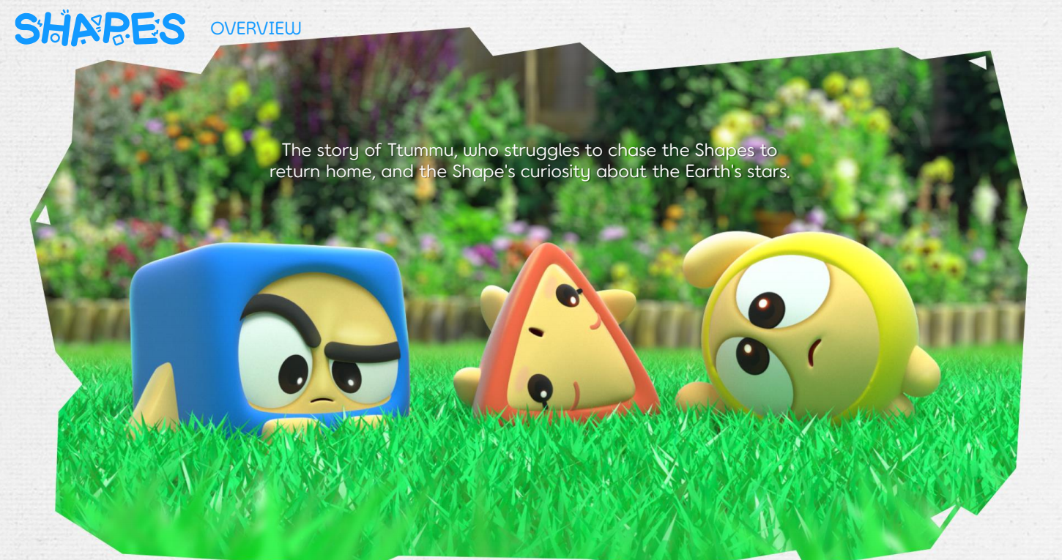
https://vimeo.com/946828754?share=copy

YOUNG&CONTENTS Short-form Drama Series

Sereal+ USA/Korea/Japan Short-form titles : 68 titles
Western Shortform : 80 titles
Chinese shortform series : 1,000 titles
Premium Chinese Micro Drama series : 13 titles
Chinese Moving toon : 39 titles
Chinese Traditional Costume Series : 46 titles
- Non-exclusive / Flat fee / etc ; Negotiable.
<Sample Video>

<Rogue's Rise> / https://www.sereal.com/reel-shorts/Rogue's Rise-280639903468105728/

- 105eps /2025.07.17/ Historical, Time Travel, Underdog's Rise/Male
- Popularity: 74.75 M + Hot Chart: No. 1, Rising Chart: No.4, New Release Chart: No.1, Heat Ranking: No.3

